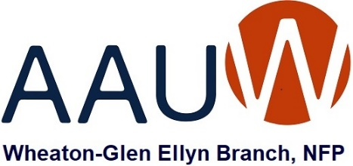

*The following questions were emailed to candidates on February 10. Responses received by the deadline of February 20 are included in our evaluation. No edits were made to any responses.*

**Martha Mueller (District 87)**

*Note: Candidate Mueller’s responses were received after the deadline. Her answers are included here for public review but were not evaluated to see if they are aligned with AAUW’s values.*

**Do you believe your school’s current Health Education curriculum should include age-appropriate sex education?  What do you see as the strengths and/or areas needing improvement in this curriculum?**

1a) Most definitely. The teen years consist of the most physical and mental changes to experience. Without educating them they're left to their peers influences or all the availability on social media. Lacking parental input, places that responsibility on other educators/mentors.

1b) Teens need to know the negative consequences of sex besides pregnancy and STD. Social media has excellerated their risks of exposure to those that want to harm them. Teaching them how to recognize and protect themselves from domestic violence and human trafficking Will Save Lives. Recognizing mental health issues and knowing where to get help is vital. Every school shooting includes "they were bullied". So let's focus on listening to our kids and offering them better options.

**What is your position on the renewal of the Invest in Kids Scholarship Tax Credit Program?  Do you favor state tax credits or vouchers for use by families to send children to private schools?  If so, how do you feel this will affect public schools?**

Access to education should not be based on wealth. Tax credits are nice unless they pull directly from local community funding. Private schools need to include access to special education needs. If a child needs assistance then a voucher would be beneficial to meeting those needs. If private school was easily accessible then public schools would need to continue to offer competive quality education. Ie: adjusting classroom sizes. I need more details of what pros/cons these programs actually offer to offer my full opinion.

**What should happen if a group of parents demands that certain books about LBGTQ teenagers be permanently removed from all Glenbard libraries. Should Glenbard censor its libraries’ content when parents object to certain books that are available for check-out but are not required reading?**

Targeting a specific group based on their personalities or beliefs should never be acceptable. If the library books aren't part of the curriculum, and are not considered pornographic, then we should defer to age appropriate freedom of choice. Every parent still has the right to set guidelines for their own minor child but they do not get to dictate what other parents choose. The school has to equally protect all the students so mulitple policys have been set to insure the library choices comply.

*Mueller (D87) – Page 2*

When this issue was brought to my attention: My first response was "No, No way should porno be available at school." After investigating and educating myself on the actual facts I realized that a storyline that includes ones curiosities with same sex situations does not fall into the definition of porn. Why are "The Book Burners" only singling out the LGBTQ story books?